The max-flow min-cut theorem is a network flow theorem. This theorem states that the maximum flow through any network from a given source to a given sink is exactly the sum of the edge weights that, if removed, would totally disconnect the source from the sink. In other words, for any network graph and a selected source and sink node, the max-flow from source to sink = the min-cut necessary to separate source from sink. Flow can apply to anything. For instance, it could mean the amount of water that can pass through network pipes. Or, it could mean the amount of data that can pass through a computer network like the Internet.
Max-flow min-cut has a variety of applications. In computer science, networks rely heavily on this algorithm. Network reliability, availability, and connectivity use max-flow min-cut. In mathematics, matching in graphs (such as bipartite matching) uses this same algorithm. In less technical areas, this algorithm can be used in scheduling. For example, airlines use this to decide when to allow planes to leave airports to maximize the "flow" of flights.
Intuition
All networks, whether they carry data or water, operate pretty much the same way. The network wants to get some type of object (data or water) from the source to the sink. The amount of that object that can be passed through the network is limited by the smallest connection between disjoint sets of the network. Even if other edges in this network have bigger capacities, those capacities will not be used to their fullest.
In the example below, you can think about those networks as networks of water pipes. Each arrow can only allow 3 gallons of water to pass by. So, the network is limited by whatever partition has the lowest potential flow.
1. \ Look at the following graphic. It is a network with four edges. The source is on top of the network, and the sink is below the network. Each edge has a maximum flow (or weight) of 3. How much flow can pass through this network at any given time?
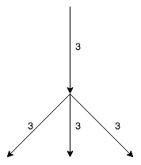Network example 1
The answer is 3. The bottom three edges can pass 9 among the three of them, true. However, the limiting factor here is the top edge, which can only pass 3 at a time. This is the intuition behind max-flow min-cut. The minimum cut will be the limiting factor.
As you can see in the following graphic, by splitting the network into disjoint sets, we can see that one set is clearly the limiting factor, the top edge. The top set's maximum weight is only 3, while the bottom is 9. The top half limits the flow of this network.
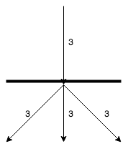The same network split into disjoint sets

2. \ What's the maximum flow for this network?
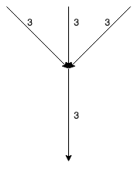Network example 2
Show Answer

The answer is still 3! The limiting factor is now on the bottom of the network, but the weights are still the same, so the maximum flow is still 3. The same network, partitioned by a barrier, shows that the bottom edge is limiting the flow of the network.
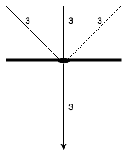The same network, partitioned
Let's look at another water network that has edges of different capacities.
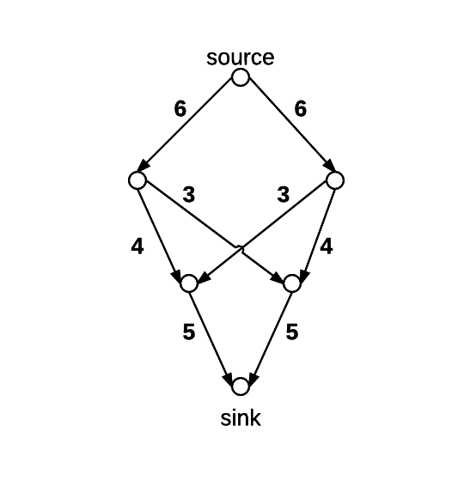
In this graphic, each edge represents the amount of water, in gallons, that can pass through it at any given time.
1. \ What is the max-flow of this network?
Show Answer

The answer is 10 gallons. Let's walk through the process starting at the source, taking things level by level:
1) 6 gallons of water can pass from the source to both vertices at the next level down. That makes a total of 12 gallons so far.
2) From here, only 4 gallons can pass down the outside edges. However, there is another edge coming out of each edge that has a capacity of 3. 4 gallons plus 3 gallons is more than the 6 gallons that arrived at each node, so we can pass all of the water through this level.
3) From this level, our only path to the sink is through an edge with capacity 5. That means we can only pass 5 gallons of water per vertex, coming out to 10 gallons total. That is the max-flow of this network.
It's important to understand that not every edge will be carrying water at full capacity. This is one example of how the network might look from a capacity perspective. Now, every edge displays how much water it is currently carrying over its total capacity.
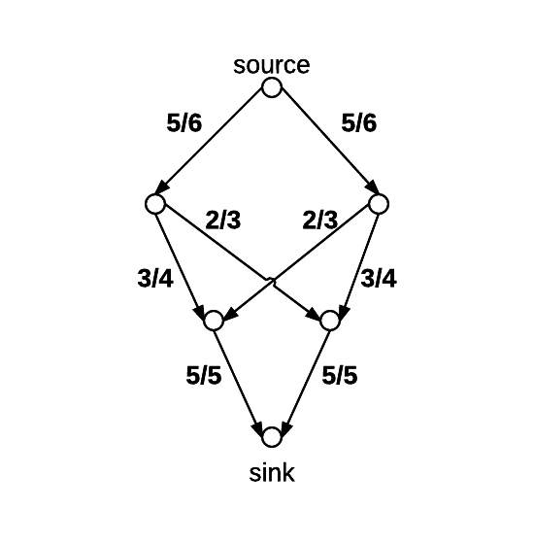Water flow

network capacity

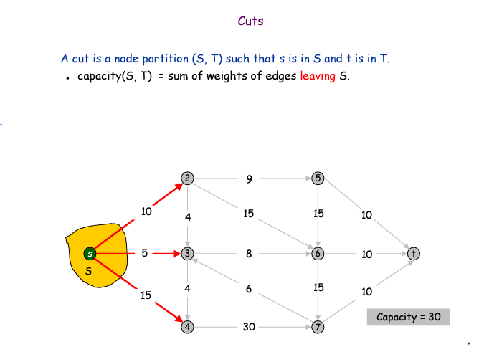

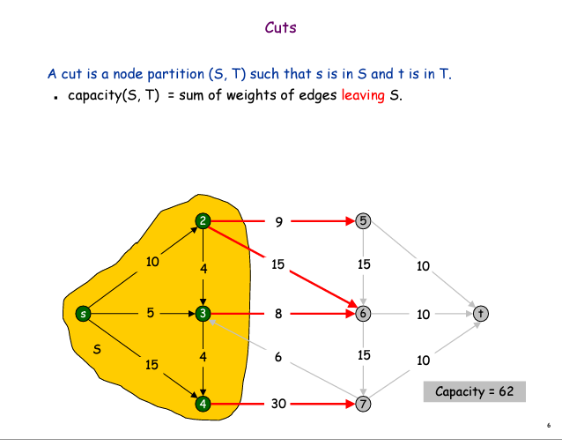

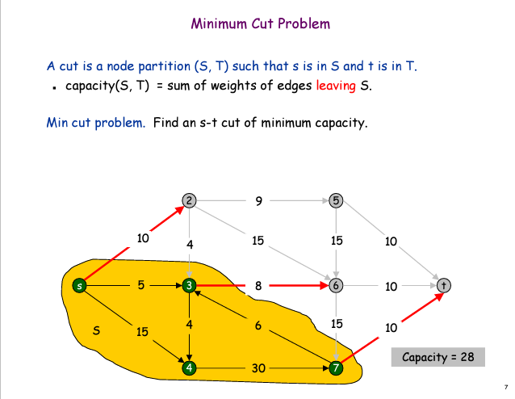

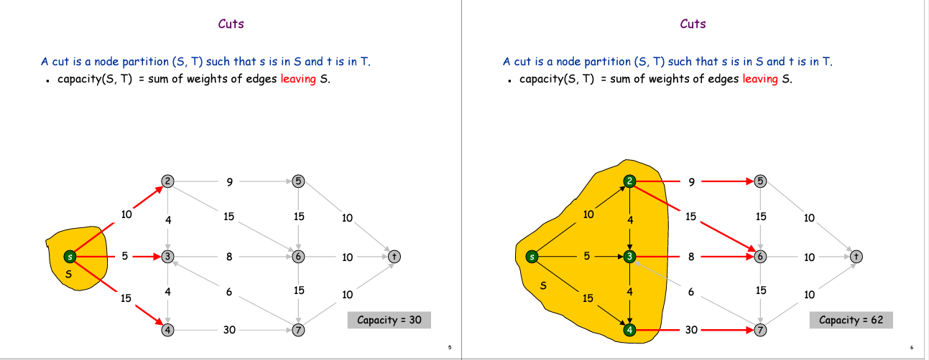

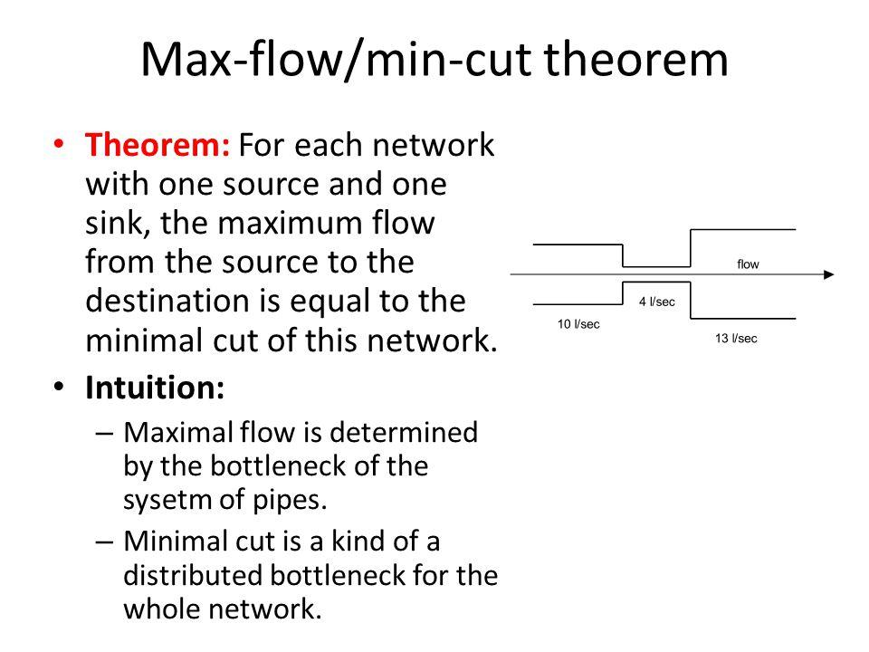

Let’s see an example:
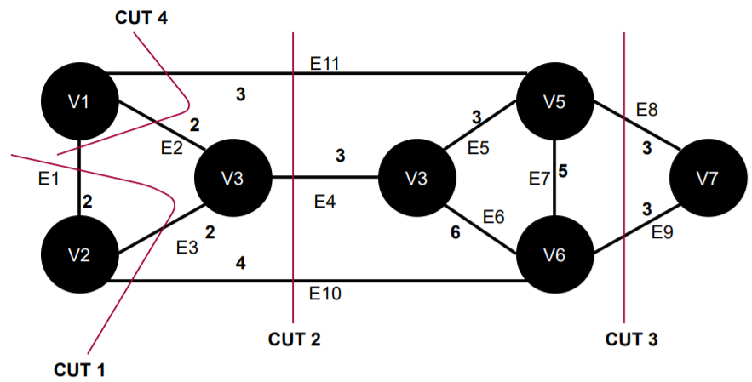
Here in this graph, is an example of a minimum cut. It removes the edges and , and the sum of weights of these two edges are minimum among all other cuts in this graph.

Technical Overview
There are a few key definitions for this algorithm. First, the network itself is a directed, weighted graph. That is, it is composed of a set of vertices connected by edges. These edges only flow in one direction (because the graph is directed) and each edge also has a maximum flow that it can handle (because the graph is weighted).
There are two special vertices in this graph, though. The source is where all of the flow is coming from. All edges that touch the source must be leaving the source. And, there is the sink, the vertex where all of the flow is going. Similarly, all edges touching the sink must be going into the sink.
A cut is a partitioning of the network, GG, into two disjoint sets of vertices. These sets are called SS and TT. SS is the set that includes the source, and TT is the set that includes the sink. The only rule is that the source and the sink cannot be in the same set. A cut has two important properties. The first is the cut-set, which is the set of edges that start in SS and end in TT. The second is the capacity, which is the sum of the weights of the edges in the cut-set. Look at the following graphic for a visual depiction of these properties.
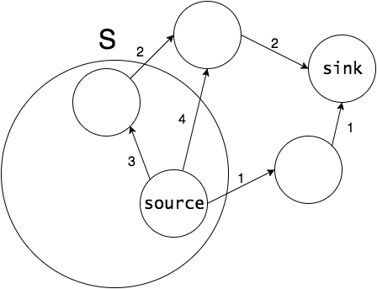Cut S with capacity 7
In this picture, the two vertices that are circled are in the set S, and the rest are in TT.
S has three edges in its cut-set, and their combined weights are 7, the capacity of this cut. The goal of max-flow min-cut, though, is to find the cut with the minimum capacity.
Algorithm
There are many specific algorithms that implement this theorem in practice. The most famous algorithm is the Ford-Fulkerson algorithm, named after the two scientists that discovered the max-flow min-cut theorem in 1956.
Proof
- Cut
  - Definition: a cut of a network
      - Cut = a set of edges whose removal will divide/separate the network into 2 halves X and Y where:
          - (source) S ∈ X and
          - (sink) T ∈ Y

      - In other words:
          - Removing the edges in a cut will severe the source S from the sink T

  - Example: 2 cuts in the network
      - Cut 1:
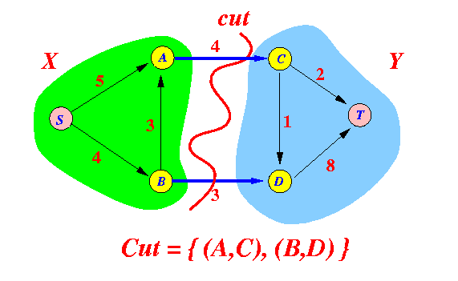

      - Cut 2:
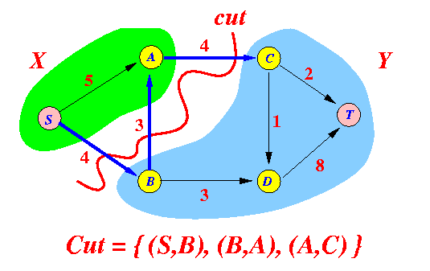

- Capacity of a cut
  - Definition: the capacity of a cut
      - Capacity of a cut = the sum of the capacity of the edges in the cut that are oriented from a vertex ∈ X to a vertex ∈ Y

Note:
          - These edges can be used to "carry" flow from S → T

Example: capacity of cuts
      - Cut 1:
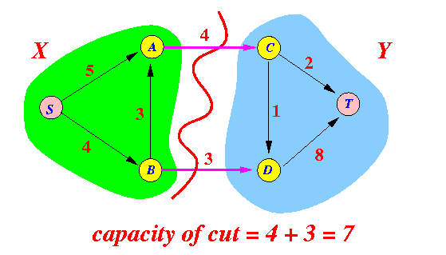

      - Cut 2:
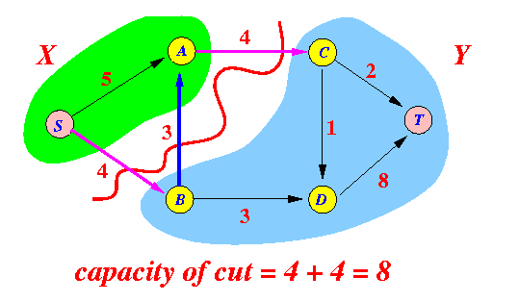
      - Note:
          - The capacity of edge B → A is not included in the sum because B → A is directed from a vertex in Y to a vertex in X
          - Only edges oriented from a vertex in X to a vertex in Y are used to "carry" flow from S → T !!!

- Minimum cut (and: minimum cut capacity)
  - Definition: minimum cut and min. cut capacity
      - Minimum cut = the cut in the network that has the smallest possible capacity

      - Minimum cut capacity = the capacity of the minimum cut

- An upper bound for the maximum flow
  - Recall: maximum flow:
      - Maximum flow = the largest possible flow from source S to sink T

  - Proposition:
Maximum flow ≤ Capacity of the min. cut of the network

Proof:
      - Consider any cut of the basic network:
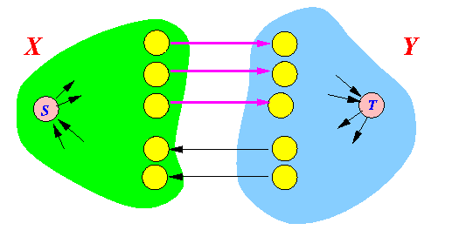
      - Note that:
          - Any flow must pass through the edge of a cut
We have that:
Total flow = ∑ _{forward edge e} f(e) - ∑ _{backward edge b} f(b)

≤ ∑ _{forward edge e} f(e) (f(e) ≤ c(e))

≤ ∑ _{forward edge e} c(e)

          - Therefore:
Total flow ≤ capacity of any cut

      - This is true for every flow
          - So it is true for the maximum possible flow also...
Therefore:
Maximum flow ≤ capacity of any cut

  - If the maximum flow ≤ capacity of any cut, then maximum flow ≤ capacity of the minimum cut:
Maximum flow ≤ capacity of minimum cut .......... (1)

- The max-flow, min-cut theorem
  - Theorem:
      - In any basic network, the value of the maximum flow is equal to the capacity of the minimum cut
I.e.:
maximum flow = capacity of min. cut

  - Proof:
      - From the previous discussion, we have that:
maximum flow ≤ capacity of min. cut

      - To complete the proof, we show that:
          - There exists a cut C such that:
capacity of cut C = maximum flow

We will construct the cut C from a maximum flow....

      - Assume that we have found a maximum flow in the network
Now construct the following cut:
          - X = set of vertices that can be reached from source S through a flow-augmenting path
          - Y = all the other vertices
Example:
          - Here is a basic network with a maximum flow:
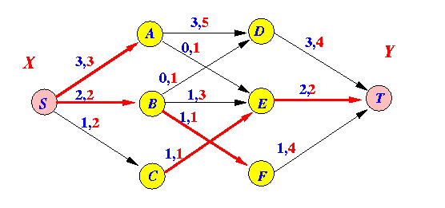

          - Nodes that can reached from source S through a flow-augmenting path:
only the node: C

          - This is the cut that we will construct:
